



Rowing

for

All

**Contents**

**1 Welcome to SABC**

**2 Communication**

2.1 Key Contacts

2.2 How we communicate

2.3 What you need to do next

**3 Membership**

3.1 Membership categories

3.2 Membership payments

3.3 Cessation of membership

**4 Code of Conduct**

4.1 Club coaches, officials and volunteers

4.2 Full Members

4.3 Junior Members

4.4 Parents/carers

**5 Squad Organisation**

5.1 Seniors

5.2 Juniors

5.3 Coxes

**6 Operational Information**

6.1 Facilities

6.2 Fleet

6.3 Learn to Row

6.4 Training

6.5 On / Off the water checklists

6.6 Canal circulation pattern

6.7 Boat maintenance

6.8 Racing

**7 Health and Safety**

7.1 Club safety and documents

7.2 Emergency contacts

7.3 Child Protection

7.4 Member welfare

7.5 Capsize

7.6 Security

**8 Helping the Club Prosper**

8.1 Volunteers

8.2 Sponsorship

**9 Kit and Merchandise**

**10 Notable Dates**

**11 Constitution and Management**

11.1 Club Organisation

11.2 The Committee and AGM

11.3 Data Protection

**Appendix**

A Location map

B Outing checklists

C Canal circulation pattern

D Basic boat maintenance

# 1 Welcome to SABC

Congratulations on becoming a member of the oldest and only open amateur rowing club in Edinburgh.

We want you to have a great experience as valued member of our club, while at the same time fulfilling your potential.

Established in 1846, we are proud to continue this tradition of rowing on the Union Canal from our Meggetland boathouse in Edinburgh.

Notable former members include world class athletes Katherine Granger and Sinéad Lynch (née Jennings).

As an open rowing club, our motto ‘Rowing for All’ drives everything we do, and rowers of all aspirations are welcomed. We have a vibrant community of rowing enthusiasts of all ages.

The club is run entirely by volunteers, who give up an enormous amount of their time to enable its members to enjoy the sport. If you are willing and able to help in any way (no matter how small, there are always jobs to do!) it would be greatly appreciated.

Please read this handbook carefully. In it you will find everything you need to know to help you get the most from your membership. If there’s anything you need to know, help is at hand, from your coach, via the website, or from the key contact list in Section 2.1 of this handbook.

And so, a warm welcome now to St Andrew Boat Club, I hope that you will soon feel at home, and wish you plenty of happy rowing!

Lindsay

Lindsay Flockhart

Captain, St Andrew Boat Club

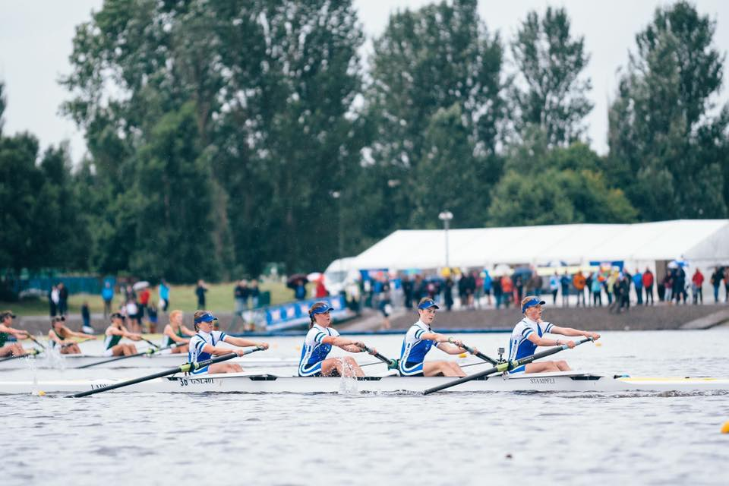

# 2 Communication

## 2.1 Key Contacts

|  |  |  |
| --- | --- | --- |
| **Position** | **Name** | **Email** |
| President | Sarah Whitley | [sabcpresident1@gmail.com](mailto:sabcpresident1@gmail.com) |
| Captain | Lindsay Flockhart | [sabccaptain@gmail.com](mailto:sabccaptain@gmail.com) |
| Vice Captain (Men) | Simon Lloyd | [sabc.mensvc@gmail.com](mailto:sabc.mensvc@gmail.com) |
| Vice Captain (Women) | Catriona Duke | [sabc.womensvc@gmail.com](mailto:sabc.womensvc@gmail.com) |
| Secretary | Iain Wilson | sabcsecretary1@gmail.com |
| Treasurer | Hal Thompson | standrewbc.treasurer@gmail.com |
| Membership Secretary | Susan Branigan | sabcmemsec@gmail.com |
| Junior Coordinator | Tom Duke | sabc.junior.rowing@gmail.com |
| Child Protection Officer | Elizabeth Thompson | [sabc.cpo@gmail.com](mailto:sabc.cpo@gmail.com) |
| Senior Coordinator | Iain Wilson | sabcsecretary1@gmail.com |
| Learn To Row Coordinator | Robert Young | sabclearntorow@gmail.com |
| Kit Secretary | Matt Gilliver | mattgilliver@yahoo.com |

**Other related pages:**

Scottish Rowing [www.scottish-rowing.org.uk](http://www.scottish-rowing.org.uk)

Strathclyde Park [www.northlanarkshire.gov.uk](http://www.northlanarkshire.gov.uk)

Weather [www.bbc.co.uk/weather](http://www.bbc.co.uk/weather)

British Rowing [www.britishrowing.org](http://www.britishrowing.org)

## 2.2 How we communicate

We have a number of publicly accessible platforms through which we communicate, internally as well as externally, as well as private social media groups.

We require members to join certain groups/platforms, and on cessation of membership, contact details will be removed either by the club or the individuals themselves, depending on the application. The platforms we use externally and internally are outlined in the tables below.

## 2.3 What you need to do next

Sign up for relevant apps and communication groups, and start to get phone numbers from team-mates.

|  |  |  |  |
| --- | --- | --- | --- |
| Internal communication platforms (club members only) | | | |
| **Source** | **Description** | **Managed By:** | **Member participation:** |
| Fitclub.me *(seniors only)* | This is a sports management app that provides a platform for noting attendance, providing events diary, team communication and member details.  This is linked to your email address, so all messages will come to registrants inbox as well. | It’s overseen by a nominated committee member, and squad leaders will base squad selection for outings, training and racing on data held within. | All senior members must sign up for this app and maintain their attendance as well as check for updates through this platform. Ensure to accept fitclub.me as an email contact to prevent emails going to spam. |
| Facebook | ‘St Andrew Boat Club’ closed group. | Overseen by identified owner, and populated by all members in group discussion. | Members who are active on social media are invited to join this group, as the bulk of everyday communications will go through this site. |
| Email | Notices and general information will be placed on closed Facebook page for all club members. Critical information will also be sent via email for the benefit of those not signed up to social media. Please note that the onus is on the individual to check their email inbox on a regular basis. | Relevant squad coordinators | Check emails daily to ensure important messages are not missed. |
| Other | Individual squads may also make their own contact groups on FB Messenger, WhatsApp, Snapchat etc. | Relevant squad coordinators | Check daily to ensure important messages are not missed. |

|  |  |  |
| --- | --- | --- |
| External communication platforms (public) | | |
| **Source** | **Description** | **Managed By:** |
| Website | standrewboatclub.com  The website is open to all, and contains much of the operational information we need to communicate, as well as partner links (such as Scottish Rowing, British Rowing, Energy Gym, other clubs using the canal etc) | The website is managed by a committee member and occasional updates will be posted on our News page link – such as Learn to Row course dates and registration, fees and subs, success stories on and off the water, good to know stuff in general. |
| Facebook  Twitter | ‘St Andrew Boat Club’ open page  @StAndrewBC handle | These pages are maintained by a committee member and updated regularly with news and results |

# 3 Membership



## 3.1 Membership categories

Membership is on an annual basis. Subscription rates are reviewed annually and are payable 1st September each year, or monthly, to cover membership until 31st August of the following year. Annual rates are published on the website.

Juniors (There is a discount of 50% for junior/cadet members who have a parent who is a full member)

Additionally, juniors are expected to attend indoor training, including erg sessions. These sessions are prepaid monthly whether the junior attends or not. These fees cover the cost of gym and equipment hire. Indoor sessions available for the relevant junior squads are as follows:

* Tuesdays: learner & developers
* Sundays: transition & aspirants
* Fridays: developers, transition & aspirants

## 3.2 Membership payments

St Andrew Boat Club members are responsible for keeping their membership up to date. If membership subscription is owing, the member will not be allowed to race until outstanding amounts are collected.

Payment

This can be made directly to the SABC account (with your name as reference).

Royal Bank of Scotland, account: 00264490, sort-code 83-18-28.

All members must also take out Scottish Rowing membership, which covers a racing licence and public liability insurance cover <https://scottishrowing.azolve.com>

## 3.3 Cessation of Membership

Written notice of leaving the club should be given to relevant captain and Membership Secretary and direct debit or standing order for membership payment cancelled.

# 4 Code of Conduct

St Andrew Boat Club is committed to safeguarding and promoting the wellbeing of all its members. The club believes that it is important that members, coaches administrators and parents associated with the club should, at all times, show respect and understanding for the safety and welfare of others. Therefore, members are encouraged to be open at all times and where necessary to share any concerns or complaints that they may have about any aspect of the club through the relevant captain or member of the committee.

## 4.1 Club coaches, officials and volunteers

Good ethical conduct and practice in relation to children and young people requires that all coaches, officials and volunteers must:

* Consider the well-being and safety of athletes before the development of performance
* Establish supportive, positive environments for the purpose of healthy competition, skill development, fun and achievement
* Develop an appropriate working relationship with athletes, based on mutual trust and respect
* Ensure that all activities are appropriate to the age, ability and experience of the athletes taking part
* Promote the positive aspects of rowing and fair play by showing considerate regard for athletes, personnel, parents, spectators and officials; abiding by the rules of racing; and abiding by officials’ decisions
* Display consistently high standards of personal behavior and appearance
* Where appropriate, hold valid leadership or coaching qualifications and insurance cover
* Follow all guidelines laid down by Scottish Rowing
* Ensure all incidents on or off the water are reported and recorded in the appropriate manner

## 4.2 Full Members

The Club expects that as a Full Member you shall:

* Follow safe practice at all times and adhere to the rules of Scottish Rowing when training on the water
* Show respect for other club members and participants, opponents, parents, spectators and officials and their decisions
* Be on time for training and competitions or inform the coach if going to be late
* Wear suitable kit for training and racing as advised by the coach and always bring a change of clothes
* Pay any charges for training or events promptly
* Help with all club fundraising activities
* Abide by the club rules and the rules of racing
* Report any collisions, damage to equipment etc to the club captain within 24 hours and fill in any incident reports necessary
* Ensure the clubhouse is left in a safe and secure state when leaving the building
* Always clear equipment away when finished with, leaving the boathouse in a clean and safe state
* Help maintain equipment by cleaning boats and oars each time after use and replacing missing/damaged parts where necessary. More serious damage to boats etc should be reported to the Club Captain immediately so that repairs can be carried out as necessary
* Willingly volunteer to help with marshalling and other duties at all club events
* Show loyalty to their club and fellow members
* Attend all relevant meetings which may concern you or your section when called in order that you can be kept up to date with any matters arising

## 4.3 Junior Members

The Club expects that as a Junior Member you shall:

* Show respect for other club members and participants, opponents, parents, spectators and officials and their decisions
* Be on time for training and competitions or inform the coach if going to be late
* Wear suitable kit for training and racing as advised by the coach and always bring a change of clothes
* Pay any charges for training or events promptly
* Never smoke or consume alcohol or drugs of any kind on the club premises or whilst representing the club
* Help with fundraising activities and club events
* Always wash club equipment after use
* Show loyalty to their club and fellow members

## 4.4 Parents/carers

The Club expects that as a parent/carer of a junior member you shall:

* Support your child’s involvement and help them to enjoy their sport, never forcing them to take part
* Help your child to recognise good performance, not just results
* Never punish or belittle your child for losing or making mistakes
* Encourage fair play and respect for officials’ decisions
* Help support club coaches by acting as spotters when requested
* Help the club in its fundraising efforts
* Never leave a child at the clubhouse without first checking that their coach is present and the training session is taking place

# 5 Squad Organisation

## 5.1 Seniors

The senior squad (which incorporates Masters, i.e. a rower aged 27+) is made up of three groups. Each squad has their own training sessions and there are pathways between each.

Senior 1 – competitive athletes with prior experience, who are able to meet the selection criteria (invitation only: please contact one of the Vice Captains for details). They follow the training schedule set by the Programme Coach and would expect to be training up to 7 days each week, recording regular assessment pieces. This group has season objectives that include Head of the River, Scottish Rowing Championships and Henley Royal Regatta, among others.

Senior 2 – this group is made up of athletes with prior experience, who train regularly 5 times a week and aim to race at various events throughout the season. Entry to this group is also by selection, based on commitment, experience and fitness.

Senior 3 – comprises:

* Recent graduates of the Learn to Row Programme (see below)
* Less experienced rowers
* Those members who are unable to train regularly.

This group may participate in some local events, as appropriate.

## 5.2 Juniors

The junior squad is run by the Junior Co-Ordinator and is well-supported by a team of coaches and volunteers. There are usually around forty young rowers, who range from twelve up to eighteen and from beginners up to those pursuing national selection.

In order to make the best use of our equipment and training slots, the juniors are divided into four groups, which are:

Learners – have started rowing relatively recently and are still getting to grips with the technical side of rowing. The Learners train once or twice (depending on the time of year) on the water and once on land each week.

Developers – have sufficient experience and technical competence to train more regularly and to start racing. The developers do up to three water and two land sessions each week.

Transition – athletes who are showing the intent and progress to become serious competitors. Can do up to four supervised water and three land sessions each week.

Aspirants – rowers who have a realistic chance of competing for Scotland or GB in the current season.

## 5.3 Coxes

All SABC squads require competent and enthusiastic coxes for steering larger boats – fours/quads on the canal and eights at Strathclyde Park. The responsibilities of a cox are outlined below:

* The cox uses a rudder to steer the boat and wears a headset microphone (a ‘cox box’) to relay clear and concise instructions to a crew.
* The canal can be tricky to steer so a new cox must take time to learn the bends and circulation pattern (see appendix C for map).
* Comply with health and safety, including wearing a life-jacket (stored in boathouse) and passing a swim test and capsize drill.
* Take care of coxing equipment and ensure the safety of their crew on the water.

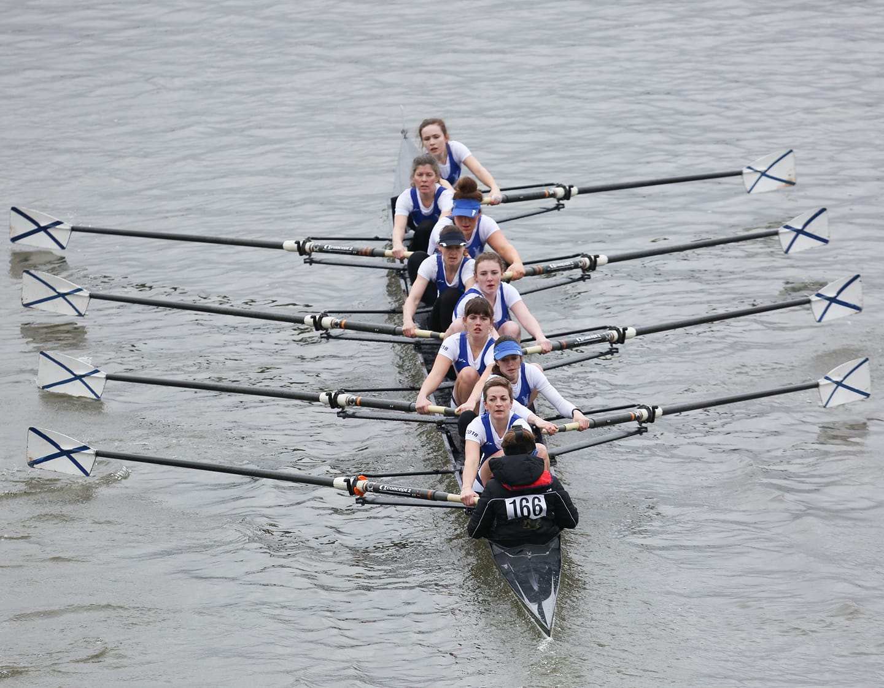

# 6 Operational Information

## 6.1 Facilities

SABC boat club is located at Meggetland Wynd, off Colinton Road. The current boathouse, built in 1984, is situated next to the Union Canal, and stands opposite Boroughmuir Rugby Club (see Appendix A for map). There are plans to develop a new boathouse and improve the Club’s land training facilities to further develop all aspects across the age and ability range.

Most training takes place on the Union Canal - members row on a 1,500 metre stretch of the Union Canal, affectionately known as ‘The Ditch’. Training sessions may also take place at Strathclyde Country Park (2 km, 8-lane, Olympic-standard course), Dullatur or Loch Ore.

Boathouse facilities (on-water)

The boathouse features boat storage and two changing rooms (with shower and WC). Access is via a key fob, granted to committee and other selected members.

We share the stretch of water with several other rowing clubs and, as the canal is not large enough to accommodate everyone, each boat club has its own allocated water session (full timetable in boathouse). This is a goodwill agreement and we depend on all respecting the time slots in order for it to keep working.

The current SABC canal sessions are:

Monday: 17:00 Juniors, 18:30 Senior 3

Tuesday: 17:00 Juniors, 18:30 Senior 1

Wednesday: 18:30 Senior 2

Thursday: 17:30 Juniors

Friday: Unallocated

Saturday: 07:30 Senior 1, 12:00 Juniors

Sunday: 07:30 Senior 1, 09:00 Senior 2 & 3, 12:00–13:30 Juniors

In addition, the canal has unallocated time on weekday early mornings. If you wish to go out on the canal at an unallocated time, you will need to arrange access through an existing keyholder (usually one of the captains). To request a key fob, you must complete a competency assessment, or alternatively keep your private scull at the club.

Indoor gym facilities (off-water)

Currently, paid up SABC members benefit from discounted entry to the Energy Gym (located in the basement of the Boroughmuir Rugby Club/Canalside building across the road). To use the gym, you will be required to sign your name and SABC in the log in sheet at the gym reception.

## 6.2 Fleet

The boathouse stores both club and private boats. The boats are graded gold, silver or bronze based on their usability for specified squads (below). Grading information can be found on the boat racking or from one the captains.

* Gold boat usage is only by express permission from the Captain.
* Silver boats are suitable for more experienced rowers (Senior 1-2 and J16+).
* Bronze boats are suitable for less experienced members.

Each boat is also rigged so that it is suitable for club use.The oars for each boat are named and stored in allocated racking around the boathouse. These should not be altered without permission. Should you wish to alter the oars or rig of any club boat, permission needs to be obtained from the Captain.

## 6.3 Learn to Row

For those who are completely new to rowing, prior to becoming a member, St Andrew Boat Club offers a ‘learn to row’ programme at various times during the year, for both senior and junior levels. The course usually runs over a number of weekend afternoons both on, and off the water. We charge a small fee to cover boat maintenance and general overheads.

The aim of Learn to Row is to get you out on the water as much as possible. The course, which is endorsed by Scottish Rowing/British Rowing, covers:

* Safety, both on and off the water.
* Identify boats and equipment that you will be using.
* Know what clothing to wear.
* Learn the correct rowing technique.

If you would like to find out more, please contact the LTR Coordinator:

[sabclearntorow@gmail.com](mailto:sabclearntorow@gmail.com)

## 6.4 Training

Senior 1 and 2 follow the training programme set by their squad coach, and the juniors follow the training programme set by the Junior Co-Ordinator. Most training takes place on the canal or in the gym, however it is possible to arrange outings to Strathclyde Park or Dullatur through squad leaders. Please contact the relevant Vice Captain for more information.

## 6.5 On / Off the water checklists

No matter how many boats out at any one time, we follow a strict routine to ensure efficiency, security and most of all, safety. Not only must we consider the rowers themselves, but also other canal and towpath users. Detailed checklists can be found in Appendix B

Daylight saving/night Rowing – please note on the water in winter-time/night will necessitate the use of bow and stern lights (we use white bow light and red stern light). All rowers need to purchase a set of lights.

## 6.6 Canal circulation pattern

Given the restricted width of the canal, and in consideration of other users, all rowing clubs agree to a circulation pattern (see Appendix C for map and diagram). Crews rowing out of town have priority passage, and those rowing into town must pull in to give way. All crews have a responsibility to check regularly for oncoming boats and give the ‘AHEAD’ warning call in good time. When in doubt, shout!

During the warmer months, there is a considerable amount of barge activity on the water. In this case, the rule is pull in, no matter your direction.

## 6.7 Boat maintenance

It is everybody’s responsibility to ensure boats are maintained and in good order. To achieve this boats must be cleaned thoroughly after use. Boats should also be checked before and after use for hull damage/heel restraints/steering if appropriate.

Everyday checks

To prevent damage, ensure that you have clear passage before taking your boat out – this includes chocking the boat above your boat, turning in gates, clearing floor of debris. Prior to rowing, when the boat is still on the trestles, check all equipment, riggers, rudder lines, etc. This should be repeated on return from outing. Blades should also be inspected regularly for chips and cracks.

Basic maintenance (minor repairs)

Minor damage should be repaired by the rower. First inform your squad leader, enter details into the boathouse log book (orange book on desk outside female changing room), write up on white board inside main doors, and ensure a Do Not Use sign is placed on the boat. Prior to commencing any repairs, ensure boat is thoroughly dry and prepare the necessary materials. If unsure, ask for help.

For repair instructions, please go to Appendix D or contact squad leader

Major maintenance

Should major maintenance be required, enter details into the orange boathouse log book, note on the whiteboard, and contact your squad leader at the earliest opportunity for further instruction.

## 6.8 Racing

As a club, we follow the Scottish Rowing calendar and endeavour to enter as many events as possible throughout the season. This includes ‘Head’ time-trial races in autumn/winter and ‘Regatta’ side-by-side knockout races in spring/summer. At higher levels, we may also attend events organised through British Rowing, but these will be at the discretion of the Captain and Squad Captains.

Racing is based on a ‘points’ system, where you accrue points for winning races and are able to enter racing categories with rowers of similar ability (i.e. promoting ‘fair’ racing). It is essential to know how many points you have before entering a race and this can be found on your Scottish Rowing license membership account. For more information about dates, check the Scottish Rowing website.

Race entry fees and costs associated with transporting boats and equipment will be calculated at each event and participating members will be charged on that basis.

# 7 Health & Safety

## 7.1 Club safety and documents

The First Aid kit can be found at the back of the boathouse outside the Womens changing room.

For information on safety, or to report an incident on the water/in the boathouse, please log on whiteboard on inside front wall (between main doors) and contact your relevant squad leader or Vice Captain.

New members will be required to carry out a swim test and capsize drill, organised throughout the year.

All health conditions should be disclosed to the relevant squad leader and captain for safety purposes.

There are some health issues that can be encountered in inland waterways, including Weils Disease (bacterial infection) and Cryptosporidiosis (parasitic infection). Sensible preventative measures should be taken. Cuts and abrasions should be covered, shoes worn on bank sides to avoid cuts, do not swallow water and certainly never handle or eat food until you have washed.

## 7.2 Emergency contacts

* Non-emergency police, dial 101
* Emergencies, dial 999
* NHS 24, dial 111
* A&E U13, Royal Hospital for Sick Kids, Sciennes Road, EH9 1LF
* Minor Injuries Service, Western General Hospital, Crewe Road South, EH4 2XU
* A&E, Royal Infirmary of Edinburgh, Little France, EH16 4SA

## 7.3 Child Protection

Please contact the Child Protection Officer  [sabc.cpo@gmail.com](mailto:sabc.cpo@gmail.com)

## 7.4 Member welfare

If you encounter any problems during your membership, please contact your squad coordinator or defer to a Captain, as soon as possible so that your issue can be dealt with appropriately and confidentially.

## 7.5 Capsize

In the event of a live capsize during an outing, remain with your boat, attempt to get back in, and return to clubhouse immediately to warm up, then check the boat for any damage.

## 7.6 Security

Members should be aware that the boathouse and changing rooms are not secure at all times and so personal belongings and valuables are left at your own risk.

# 8 Helping the Club prosper

At SABC we are all about community and teamwork. There are a number of ways in which you can help keep our club growing, developing and improving – for our members and our community

## 8.1 Volunteers

The Club is run entirely by Volunteers. Volunteers have the opportunity to decide how much time they spend, what skills they wish to use and/or develop and how long to volunteer for the Club. In some instances, the Club may sponsor training for first-aid, coaching and other skills as agreed. Please contact your Vice Captain to discuss opportunities available.

Examples of volunteer opportunities

* Facilities and maintenance: including maintenance/repairs of grounds, fleet and boathouse
* Communication: mails, social media maintenance etc, updating website and key documents etc.
* Racing: including organising racing entries, fees etc.
* Kit: including liaising with suppliers and members
* Publicity: including creating and distributing information, leaflets, adverts
* Fundraising: including applying for grants and sponsorships

## 8.2 Sponsorship

There are a variety of levels of sponsorship opportunities to support the Club financially. Please contact the Captain for information [sabccaptain@gmail.com](mailto:sabccaptain@gmail.com)



# 9 Kit and Merchandise

Members wishing to race must wear the current SABC club one piece. Our race kit supplier is Rival Kit. There is also old-style SABC kit available from Godfrey. However, only the Rival Kit (or previously purchased kits from Powerhouse) one piece is recognised as offical SABC racing uniform by Scottish Rowing.

[https://rivalkit.com](https://rivalkit.com/)

# 10 Notable Dates

SABC attends many of the races in the Scottish Rowing Calendar (published at the start of Head season), in addition to some events in England organised by British Rowing.

Notable racing and social dates are:

* Head season (Autumn/Winter) e.g. Inverness Fours and small boats in November
* Regatta season (Spring/Summer) e.g. Scottish Championships in June
* SABC Annual Dinner in November/December
* AGM & summer party in August

Exact dates and times are confirmed closer to the time. Other whole club and squad specific social events will be communicated to relevant members via email or Facebook.

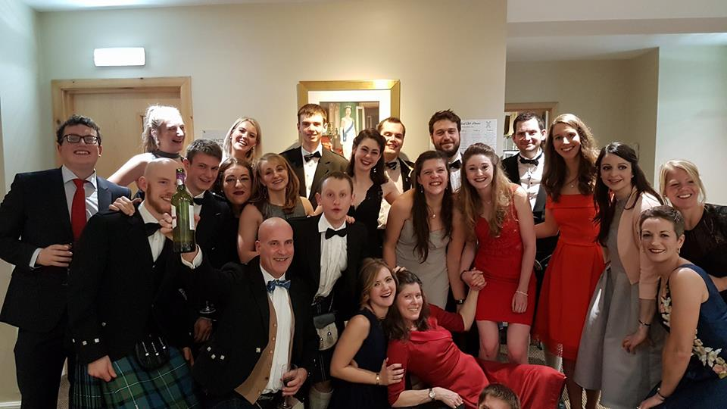

# 11 Constitution and Management

## 11.1 Club Organisation

The governing body of the Club is the Board of Trustees, which is elected at the AGM. Positions on the Board are as follows:

President

Captain

Secretary

Treasurer

4 ordinary Trustees

Minutes are available on request, from the Secretary and periodically updated in the Members page of the website.

The club is SCIO Scottish Charity (number SC045608**)** and the last submitted accounts are available on the OSCR website www.oscr.org.uk

## 11.2 The Committee and AGM

All roles are voluntary and elected on an annual basis at our AGM. Traditionally, we hold our AGM every August, prior to our Club Summer Party Barbeque.

## 11.3 Data Protection

The Club takes its data protection responsibilities seriously and has taken appropriate steps to ensure compliance with GDPR.

# Appendix

## A. Location map for St Andrew Boat Club (SABC)

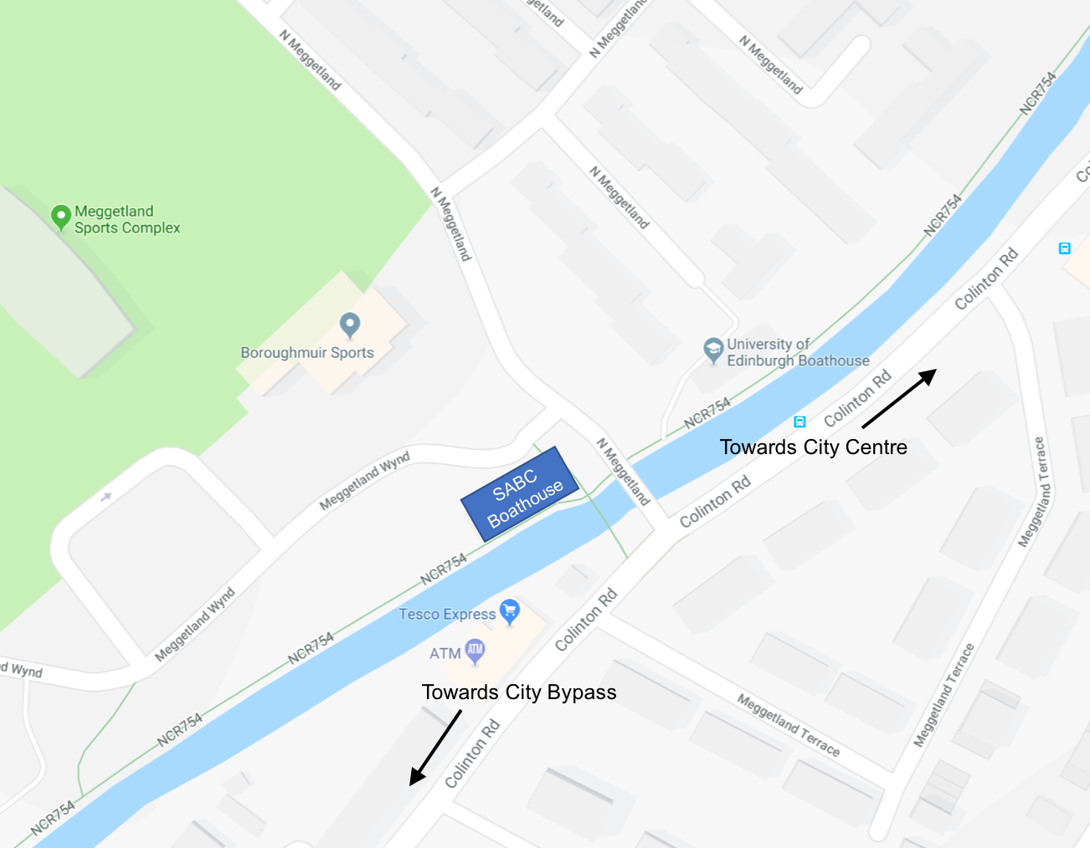

## B. Outing checklists

Important:

* Do not attempt the following steps alone, if you need help just ask someone
* If you are in a coxed boat, the cox should call and help with the following steps
* Once boated, remember the canal circulation pattern and right of ways

Boating Checklist – Remember Boat Lights in Winter

|  |  |  |
| --- | --- | --- |
|  | **Instruction** | **Tick** |
| 1 | Arrive ~15 min before ‘hands-on’ time |  |
| 2 | Ensure your crew are all there, decide on seat order and discuss outing plan |  |
| 3 | Find correct oars and take up to bank |  |
| 4 | Put out trestles |  |
| 5 | Hands-on, carry boat out of boathouse and place on trestles |  |
| 6 | Check steering, heel restraints, riggernuts and hull damage |  |
| 7 | Find your seat and alter shoes/slides |  |
| 8 | Hands-on, carry boat up to canal, check tow-path for pedestrians/cyclists |  |
| 9 | Carry boat down tow-path ‘out of town’ and spin on spot |  |
| 10 | Carry boat ‘into town’ along to concrete steps |  |
| 11 | Step down towards water |  |
| 12 | Roll boat down to waists, push right out towards the water and gently place |  |
| 13 | Find oars and place in gates |  |
| 14 | Get in boat and secure oars in gates and feet in shoes |  |
| 15 | When the whole crew is ready, lean towards canal and push off bank |  |

End of outing Checklist – Remove Boat Lights in Winter

|  |  |  |
| --- | --- | --- |
|  | **Instruction** | **Tick** |
| 1 | Quickly get out of boat and remove oars from gate |  |
| 2 | Remove oars from gate and place next to hedge with any other loose items |  |
| 3 | Hands on, lift boat out of water and carry boat up steps at waists |  |
| 4 | Check towpath for pedestrians and cyclists |  |
| 5 | Roll boat up to heads (rock for 1,2,3 and push with arms up to heads) |  |
| 6 | Carry boat out of town, past the boathouse footpath and spin on spot |  |
| 7 | Carry boat down towards boathouse at heads |  |
| 8 | Position boat bowball pointing into boathouse (spin if necessary) |  |
| 9 | Place boat on trestles |  |
| 10 | Sponge and rinse with hose, inside and outside of boat |  |
| 11 | Check for damage and report repairs if applicable |  |
| 12 | Check route to boathouse rack is clear |  |
| 13 | Carry boat bowball first into boathouse and place on named rack |  |
| 14 | Collect oars and place inside boathouse with trestles |  |
| 15 | If you are last one out of boathouse: turn off lights and ensure doors are shut. The side door needs to be closed carefully and checked, as the lock doesn’t always catch. |  |

## C. Canal circulation pattern

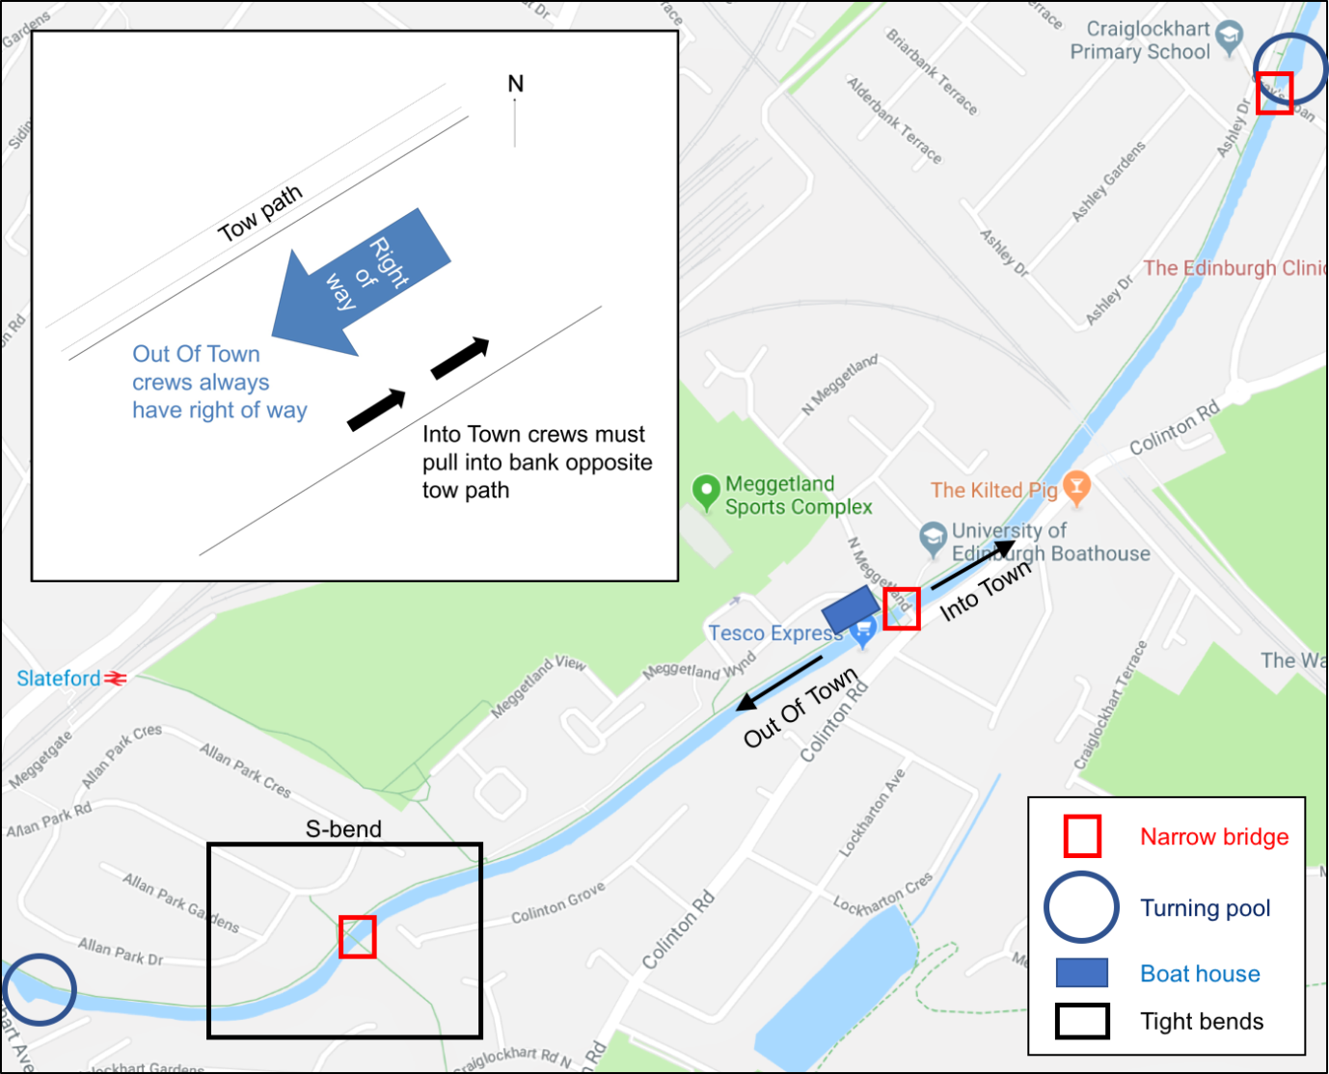

## D. Basic boat maintenance

Basic process for repair of minor dings:

* Ensure boat and damaged area is thoroughly dry
* Initial rub-down with 300-500 grit wet/dry
* Ensure all surfaces are dry and free from debris
* Fill ding with Upol and leave for a few days (at least 48 hours before going anywhere near water)
* Rub-down with 800 wet/dry until all surfaces clean and level (leave room for paint when levelling)
* Prime using high build etching primer and leave to dry
* Paint with 2-pack gloss paint (car body stuff) spray (at least 48 hours before going near water)
* 2 weeks after painting, rub down with 1200 wet/dry, then polish