



Rowing For All

Contents

1 Introduction 3

2 Club Structure 4

2.1 Office Bearers 4

2.2 Volunteers 5

3 Constitution and Management 6

3.1 Club Organisation 6

3.2 The Committee and AGM 6

3.3 Data Protection 6

4 Code of Conduct 7

4.1 Club coaches, officials and volunteers 7

4.2 Full Members 7

4.3 Junior Members 8

4.4 Parents/carers 8

5 Squad Organisation 10

5.1 Seniors 10

5.2 Juniors 10

5.3 Coxes 11

5.4 Learn to Row 11

6 Facilities 12

6.1 Facilities 12

6.2 Fleet 13

6.3 Security 13

7 On the Water 14

7.1 Outing checklists 14

7.2 Capsize 14

7.3 Canal circulation pattern 14

7.4 Boat maintenance 15

7.5 Racing 15

8 Safety 16

8.1 Club safety and documents 16

8.2 Child Welfare and Protection 16

8.3 Member welfare 16

8.4 Capsize 16

9 Fundraising and Sponsorship 17

10 Kit and Merchandise 18

11 Events 19

12 Appendix 20

A. Location map for St Andrew Boat Club (SABC) 20

B. Outing checklists 20

C. Canal circulation pattern 21

D. Useful Links: 22

Introduction

Welcome to St Andrew Boat Club - the oldest and only open amateur rowing club in Edinburgh.

We want you to have a great experience as a valued member of our club, while at the same time fulfilling your potential.

Established in 1846, we are proud to continue this tradition of rowing on the Union Canal from our Meggetland boathouse in Edinburgh.

Notable former members include world class athletes Katherine Granger and Sinéad Lynch (née Jennings).

As an open rowing club, our motto ‘Rowing for All’ drives everything we do, and rowers of all aspirations are welcomed. We have a vibrant community of rowing enthusiasts of all ages; and as a volunteer led and run club, everyone has a chance to lend a hand.

We hope you find this handbook useful - in it you will find everything you need to know to help you get the most from your membership, but if you have any questions, your vice captains will be happy to help.

And so, a warm welcome now to St Andrew Boat Club, I hope that you will soon feel at home, and wish you plenty of happy rowing!

Lindsay

Lindsay Flockhart

Captain, St Andrew Boat Club

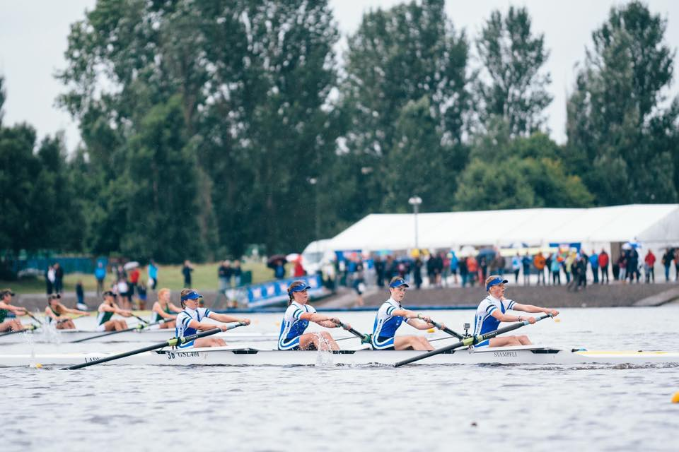

Club Structure

## Office Bearers

|  |  |  |
| --- | --- | --- |
| **Position** | **Name** | **Email** |
| President | Sarah Whitley | [sabcpresident1@gmail.com](mailto:sabcpresident1@gmail.com) |
| Captain | Lindsay Flockhart | [sabccaptain@gmail.com](mailto:sabccaptain@gmail.com) |
| Secretary | Iain Wilson | sabcsecretary1@gmail.com |
| Treasurer | Hal Thompson | standrewbc.treasurer@gmail.com |
| Vice Captain (Women) | Julia Belgutay | [sabc.womensvc@gmail.com](mailto:sabc.womensvc@gmail.com) |
| Vice Captain (Men) | Simon Lloyd | [sabc.mensvc@gmail.com](mailto:sabc.mensvc@gmail.com) |
| Junior Coordinator | Tom Duke | sabc.junior.rowing@gmail.com |
| Membership Secretary | Susan Branigan | sabcmemsec@gmail.com |
| Safety Officer | Rob Bradley | sabcsafety@gmail.com |
| Child Welfare and Protection Officer | Iona McCaul | [sabc.cpo@gmail.com](mailto:sabc.cpo@gmail.com) |
| Learn To Row Coordinator | Robert Young | sabclearntorow@gmail.com |
| Inclusion Officer | Sharon Wallace |  |
| Kit Secretary | Kit Faller |  |

As a volunteer led and run club, we rely on members and Junior parents to volunteer to help – this can take on many forms – helping at events, serving on management, fundraising or social committees, coaching, welcoming new members etc.

Do you have any specialist skills which you could bring to to club? (e.g. computing, marketing, business management, fundraising, accounting, event organisation, coaching, etc.)

If so we could really do with your help from time to time. Please contact [sabcmemsec@gmail.com](mailto:sabcmemsec@gmail.com) for further information.

## Volunteers

We ask that all members give of their time to assist with running the club - In some instances, the Club may sponsor training for first-aid, coaching and other skills as agreed. Please contact the Club President, Membership Secretary or your Vice Captain to discuss opportunities available.

Examples of volunteer opportunities

* Facilities and maintenance: including maintenance/repairs of grounds, fleet and boathouse
* Communication: mails, social media maintenance etc, updating website and key documents etc.
* Racing: including organising racing entries, fees etc.
* Kit: including liaising with suppliers and members
* Publicity: including creating and distributing information, leaflets, adverts
* Fundraising: including applying for grants and sponsorships

Constitution and Management

## Club Organisation

The governing body of the Club is the Board of Trustees, which is elected at the AGM. Positions on the Board are as follows:

President

Captain

Secretary

Treasurer

4 ordinary Trustees

Minutes are available on request, from the Secretary and periodically updated in the Members page of the website.

The club is SCIO Scottish Charity (number SC045608) and the last submitted accounts are available on the OSCR website www.oscr.org.uk

## The Committee and AGM

All roles are voluntary and elected on an annual basis at our AGM. Traditionally, we hold our AGM every August, close to the date of our Club Garden Party.

## Data Protection

The Club takes its data protection responsibilities seriously and has taken appropriate steps to ensure compliance with GDPR

Code of Conduct

In addition to the Members Charter which all members are required to sign, St Andrew Boat Club is committed the Code of Conduct in order to safeguard and promote the wellbeing of all its members.

The club believes that it is important that members, coaches administrators and parents associated with the club should, at all times, show respect and understanding for the safety and welfare of others.

Therefore, members are encouraged to be open at all times and where necessary to share any concerns or complaints that they may have about any aspect of the club through the relevant captain or member of the committee.

## Club coaches, officials and volunteers

Good ethical conduct and practice in relation to children and young people, vulnerable adults and all members in general, requires that all coaches, officials and volunteers must:

* Consider the well-being and safety of athletes before the development of performance
* Establish supportive, positive environments for the purpose of healthy competition, skill development, fun and achievement
* Develop an appropriate working relationship with athletes, based on mutual trust and respect
* Ensure that all activities are appropriate to the age, ability and experience of the athletes taking part
* Promote the positive aspects of rowing and fair play by showing considerate regard for athletes, personnel, parents, spectators and officials; abiding by the rules of racing; and abiding by officials’ decisions
* Display consistently high standards of personal behavior and appearance
* Where appropriate, hold valid leadership or coaching qualifications and insurance cover
* Follow all guidelines laid down by Scottish Rowing
* Ensure all incidents on or off the water are reported and recorded in the appropriate manner

## Full Members

The Club expects that as a Full Member you shall:

* Follow safe practice at all times and adhere to the rules of Scottish Rowing when training on the water
* Show respect for other club members and participants, opponents, parents, spectators and officials and their decisions
* Be on time for training and competitions or inform the coach if going to be late
* Wear suitable kit for training and racing as advised by the coach and always bring a change of clothes
* Report any collisions, damage to equipment etc to the club captain within 24 hours and fill in necessary incident reports
* Pay any charges for training or events promptly
* Abide by the club rules and the rules of racing
* Ensure the clubhouse is left in a safe and secure state when leaving the building
* Always clear equipment away when finished with, leaving the boathouse in a clean and safe state
* Help maintain equipment by cleaning boats and oars each time after use and replacing missing/damaged parts where able or report immediately. More serious damage to boats etc should be reported to the Club Captain immediately so that repairs can be carried out as necessary
* Willingly volunteer to help with marshalling and other duties at all club events
* Show loyalty to their club and fellow members
* Help with all club fundraising activities
* Attend all relevant meetings which may concern you or your section when called in order that you can be kept up to date with any matters arising

## Junior Members

The Club expects that as a Junior Member you shall:

* Show loyalty to club and fellow members
* Show respect for other club members and participants, opponents, parents, spectators and officials and their decisions
* Be on time for training and competitions or inform the coach if going to be late
* Wear suitable kit for training and racing as advised by the coach and always bring a change of clothes
* Inspect equipment prior to boating (hull scratches or holes, check for loose riggers, heel restraints, blades)
* Always wash club equipment after use and report any damages
* Pay any charges for training or events promptly
* Never smoke or consume alcohol or drugs of any kind on the club premises or whilst representing the club
* Help with fundraising activities and club events

## Parents/carers

The Club expects that as a parent/carer of a junior member you shall:

* Ensure fees and subs payments are made promptly
* Support your child’s involvement and help them to enjoy their sport, never forcing them to take part
* Help your child to recognise good performance, not just results
* Never punish or belittle your child for losing or making mistakes
* Encourage fair play and respect for officials’ decisions
* Help support club coaches by acting as spotters when requested
* Never leave a child at the clubhouse without first checking that their coach is present and the training session is taking place
* Help the club in its fundraising efforts

Squad Organisation

## Seniors

The senior squad (which incorporates Masters, i.e. a rower aged 27+) is made up of three groups. Each squad has their own training sessions and there are pathways between each.

A land training programme is published monthly for all athletes to follow according to their level.

Senior Women, Senior Men – competitive athletes with prior experience, who are keen to race across the UK and further afield. They follow the training schedule set by the Programme Coach and would expect to be training up to 7 days each week, recording regular assessment pieces. This group has season objectives that include Tideway Head of the River, Scottish Rowing Championships and Henley Royal Regatta, among others.

Mixed Masters – this group is made up of athletes with prior experience, who train regularly 5 times a week and aim to race at various events throughout the season.

Senior 3 – Recreational – comprises:

* Recent graduates of the Learn to Row Programme (see below)
* Less experienced rowers
* Those members who are unable to train regularly.

This group may participate in some local events, as appropriate.

## Juniors

The junior squad is run by the Junior Co-Ordinator and is well-supported by a team of coaches and volunteers. There are usually around forty young rowers, who range from twelve up to eighteen and from beginners up to those pursuing national selection.

In order to make the best use of our equipment and training slots, the juniors are divided into four groups, which are:

Learners – have started rowing relatively recently and are still getting to grips with the technical side of rowing. The Learners train once or twice (depending on the time of year) on the water and once on land each week.

Developers – have sufficient experience and technical competence to train more regularly and to start racing. The developers do up to three water and two land sessions each week.

Transition – athletes who are showing the intent and progress to become serious competitors. Can do up to four supervised water and three land sessions each week.

Aspirants – rowers who have a realistic chance of competing for Scotland or GB in the current season.

## Coxes

All SABC squads require competent and enthusiastic coxes for steering larger boats – fours/quads on the canal and eights at Strathclyde Park. Coxes will train and also compete with the senior and mixed masters groups.

## Learn to Row

For those who are completely new to rowing, prior to becoming a member, St Andrew Boat Club offers a ‘learn to row’ programme at various times during the year, for both senior and junior levels.

The aim of Learn to Row is to get you out on the water as much as possible. The course, which is endorsed by Scottish Rowing/British Rowing, covers:

* Safety, both on and off the water.
* Identify boats and equipment that you will be using.
* Know what clothing to wear.
* Learn the correct rowing technique.

On graduating from LTR, rowers will join the Recreational water sessions on Sunday mornings and Monday evenings in summer. Sunday sessions are coached by seniors and rowers can also participate in club land training programmes.

If you would like to find out more, please contact the LTR Coordinator:

[sabclearntorow@gmail.com](mailto:sabclearntorow@gmail.com)

Facilities

## Facilities

SABC boat club is located at Meggetland Wynd, off Colinton Road, next to the Union Canal and stands opposite Boroughmuir Rugby Club (see Appendix A for map).

Our facilities comprise 2 boathouses – our newly completed Boathouse (2022) includes a boat storage facility, changing facilities, showers and toilets, a coffee preparaton area, fully equipped erg room, and office.

The old boathouse, built in 1984, provides boat storage, a boat repair shop, toilets and showers for private boat owner members.

Most training takes place on the Union Canal - members row on a 1,500 metre stretch of water adjacent to the Meggetland Boathouse between the ‘middle turning circle’ at Harrison Park, and the ‘top turning circle’ at CHAS; and Strathclyde Country Park (2 km, 8-lane, Olympic-standard course), as well as Tay Rowing Club in Perth and occasionaly the water at Auchinstarry Basin at Dullatur, and Grosvenor Rowing Club in Chester for Easter training camps.

We share our stretch of water with several other rowing clubs and each boat club has its own allocated water session. This is a goodwill agreement and we depend on all respecting the time slots in order for it to keep working.

The current SABC sessions are:

* + Monday: 14:00 – 17:30 Schools, 17:00 Juniors, 18:30 Rec Rowers
  + Tuesday: 14:00 – 17:30 Schools, 17:00 Juniors, 18:45 Senior Men
  + Wednesday: 14:00 – 17:30 Schools, 17:00 Juniors, 18:45 Senior Women
  + Thursday: 14:00 – 17:30 Schools, 17:30 Juniors, 18.30 Senior Men
  + Friday: 14:00 – 17:30 Schools, Unallocated slots
  + Saturday: 07:00 Seniors, 8.30am Heriots School;12:00 Juniors
  + Sunday: 07:30 Seniors, 09:00 Recreational session, 10.30am George Watsons College, 12:00–13:30 Juniors, 13.30 Edinburgh University Club Rowing
  + Weekday mornings 6.30 – 8.30am Edinburgh University Beginners

In addition, we can avail of other unallocated times on weekdays, which are detailed on FitClub.me app. If you wish to go out on the canal at an unallocated time, you will need to sign up on Fitclub, arrange access through an existing keyholder (usually one of the captains), and be competent at launching and landing your boat. To request a key fob, you must complete a competency assessment, or alternatively keep your private scull at the club.

Indoor gym facilities (off-water)

Currently, paid up SABC members benefit from discounted entry to the Energy Gym (located in the basement of the Boroughmuir Rugby Club/Canalside building across the road). To use the gym, you will be required to sign your name and SABC in the log in sheet at the gym reception.

The erg room in the New Boathouse will also be available for use on a group allocated basis, also bookable on Fitclub.

## Fleet

Our fleet based at the boathouse consists mainly of small boats (singles, doubles, quads/fours).The boats are graded gold, silver or bronze based on their usability for specified squads (below). Grading information can be found on the boat racking or from one the captains.

* Gold boat usage is only by express permission from the Captain.
* Silver boats are suitable for more experienced rowers (Senior and J16+).
* Bronze boats are suitable for less experienced members.

Boat storage facilities are also situated at Strathclyde Park mostly in use by Senior rowers and Aspirant Juniors.

Each boat is also rigged so that it is suitable for club use.The oars for each boat are named and stored in allocated racking around the boathouse. These should not be altered without permission. Should you wish to alter the oars or rig of any club boat, permission needs to be obtained from the Captain.

Private racking is also available in the Old Boathouse.

## Security

Members should be aware that the boathouse and changing rooms are not secure at all times and so personal belongings and valuables are left at your own risk.

On the Water

## Outing checklists

Set up trestles in a diagonal format to allow turning and access into and out of the boathouse.

If trestles are already out for groups already on the water, put out additional trestles to ensure outgoing and incoming boats have adequate provision.

No matter how many boats out at any one time, we follow a strict routine to ensure efficiency, security and most of all, safety. Not only must we consider the rowers themselves, but also other canal and towpath users. Detailed checklists can be found in Appendix B

Daylight saving/night Rowing – please note on the water in winter-time/night will necessitate the use of bow and stern lights (we use white bow light and red stern light). All rowers need to purchase a set of lights.

Everyday checks

To prevent damage, ensure that you have clear passage before taking your boat out – this includes chocking the boat above your boat, turning in gates, clearing floor of debris. Prior to rowing, when the boat is still on the trestles, check all equipment, riggers, rudder lines, etc. This should be repeated on return from outing. Blades should also be inspected regularly for chips and cracks. Tennis balls should be put on gates on return from outing prior to returning boat to racks.

## Capsize

In the event of a live capsize during an outing, remain with your boat, attempt to get back in, and return to clubhouse immediately to warm up, then check the boat for any damage. Report the incident on FitClub.

## Canal circulation pattern

Given the restricted width of the canal, and in consideration of other users, all rowing clubs agree to a circulation pattern (see Appendix C for map and diagram). Crews rowing out of town have priority passage, and those rowing into town must pull in to give way. All crews in either direction have a responsibility to check regularly (e.g. every 4 strokes) for oncoming boats and give the ‘AHEAD’ warning call in good time, regardless of direction and priority. When in doubt, shout.

During the warmer months, there is a considerable amount of barge activity on the water. In this case, the rule is pull in, no matter your direction.

## Boat maintenance

It is everybody’s responsibility to ensure all equipment is in good order. To achieve this boats and blades must be cleaned thoroughly after use. Boats should also be checked before and after use for hull damage/heel restraints/steering if appropriate.

All damage to boats and or blades should be reported on the white board in the Old Boat House and incident book, and on fitclub. and ensure it is reported and acknowledged by emailing the club Captain. First inform your squad leader, enter details into the boathouse logbook (orange book on desk outside women’s changing room), write up on white board inside main doors, and ensure a Do Not Use sign is placed on the boat.

Boat maintenance is then largely carried out by the Wednesday Boatshed Group.

## Racing

As a club, we follow the Scottish Rowing calendar and endeavour to enter as many events as possible throughout the season. This includes ‘Head’ time-trial races in autumn/winter and ‘Regatta’ side-by-side knockout races in spring/summer. At higher levels, we may also attend events organised through British Rowing, such as Tideway HoRR and WEHoRR, Henley Royal Regatta, Henley Womens and Henley Masters regattas, but these will be at the discretion of the Captain and Squad Captains.

Racing is based on a points system, where you accrue points for winning races and are able to enter racing categories with rowers of similar ability (i.e. promoting ‘fair’ racing). It is essential to know how many points you have before entering a race and this can be found on your Scottish Rowing license membership account. For more information about dates, check the Scottish Rowing website.

Race entry fees and costs associated with transporting boats and equipment will be calculated at each event and participating members will be charged on that basis.

Safety

## Club safety and documents

In the Old Boat House, the First Aid kit can be found at the back of the boathouse outside the Womens changing room.

For information on safety, or to report an incident on the water/in the boathouse, please log on whiteboard on inside front wall (between main doors) and contact your relevant squad leader or Vice Captain. Incident reporting should also be logged on FitClub.

New members will be required to carry out a swim test and capsize drill, organised throughout the year.

All relevant health conditions should be disclosed to the relevant squad leader and captain for safety purposes.

There are some health issues that can be encountered in inland waterways, including Weils Disease (bacterial infection) and Cryptosporidiosis (parasitic infection). Sensible preventative measures should be taken. Cuts and abrasions should be covered, shoes worn on bank sides to avoid cuts, do not swallow water and certainly never handle or eat food until you have washed.

## Child Welfare and Protection

St Andrew Boat Club is committed to protecting our Junior members. If you have any issues of concern, please contact the Child Welfare and Protection Officer:  [sabc.cwpo@gmail.com](mailto:sabc.cwpo@gmail.com).

## Member welfare

If you encounter any problems during your membership, please contact your squad coordinator or defer to a Captain, as soon as possible so that your issue can be dealt with appropriately and confidentially.

## Capsize

In the event of a live capsize during an outing, remain with your boat, attempt to get back in, and return to clubhouse immediately to warm up, then check the boat for any damage.

Fundraising and Sponsorship

At St Andrew Boat Club we are all about community and teamwork. There are a number of ways in which you can help keep our club growing, developing and improving – for our members and our community

In order to maintain our facilities and continuously develop our fleet for our growing membership, we vitally need to raise funds on an ongoing basis to cover equipment purchases and maintenance of our new boathouse. In addition, while most of the funds for the new boathouse have been raised, there is an excess (as at September 2022) that needs to be covered before we can look to upgrading our fleet.

The club needs all members to get involved in fundraising projects large or small. If you have any ideas and would like some help, please contact Fundraising Committee in the first instance for support for your idea.

Kit and Merchandise

Members wishing to race must wear the current St Andrew Boad Club racing one piece. Our current race kit supplier is Rival Kit. There is also old-style SABC kit available from Godfrey. However, only the Rival Kit (or previously purchased kits from Powerhouse) one piece is recognised as offical St Andrew Boat Club racing uniform by Scottish Rowing.

[https://rivalkit.com](https://rivalkit.com/)

Our preferred racing kit is – Racing AIO, long or short sleeved white top.

Rival Kit time frames tend to depend on global availability so are not instantly available. For items not in stock, recommended lead times run between 4 – 10 weeks.

For new members racing, existing members not racing are usually happy to share kit in the short-term.

Events

In addition to Senior racing events, St Andrew Boat Club attends many of the races in the Scottish Rowing Calendar (published at the start of Head season

Notable races are:

* Head season (Autumn/Winter) e.g. Inverness Fours and small boats in November
* Glasgow small boats head
* Inverness Eights head in March
* Regatta season (Spring/Summer) e.g. Scottish Rowing Spring Regatta in April and Scottish Championships in June

Club social events happen throughout the year, and we hope to run more fundraising socials in our new boathouse.

Existing socials include:

* St Andrew Boat Club Annual Dinner in November/December – the closest Saturday to St Andrew’s Day
* AGM - August
* Summer party – August/September
* Sunday coffee in Canalside after Sunday morning rowing
* Monthly Pot luck suppers in the boathouse

Exact dates and times are confirmed closer to the time. Other whole club and squad specific social events will be communicated to relevant members via email, facebook/social media platforms, and noticeboards.

Appendix

## A. Location map for St Andrew Boat Club (SABC)

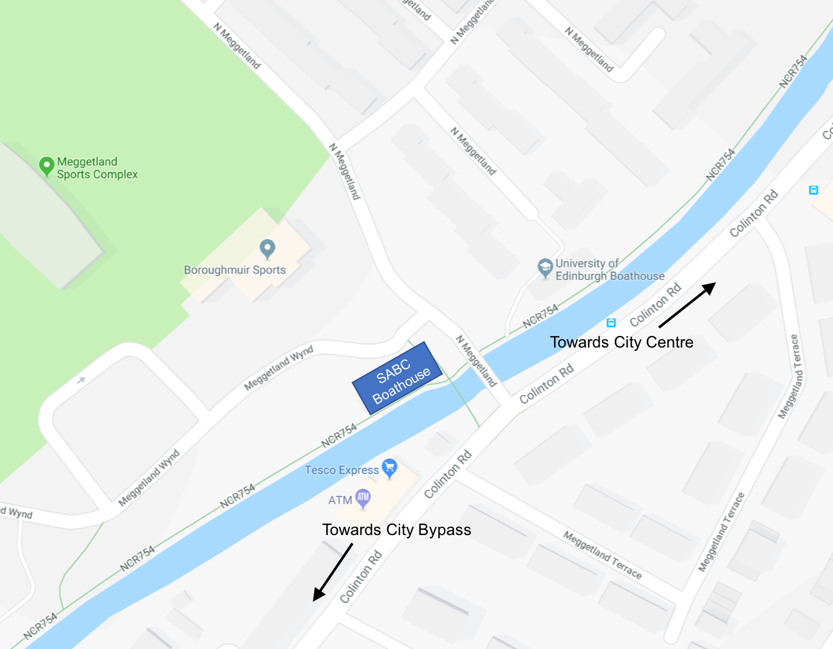

## B. Outing checklists

Important:

* Do not attempt the following steps alone, if you need help just ask someone
* If you are in a coxed boat, the cox should call and help with the following steps
* Once boated, remember the canal circulation pattern and right of ways

**Boating Checklist – Remember Boat Lights in Winter**

|  |  |  |
| --- | --- | --- |
|  | **Instruction** | **Tick** |
|  | Arrive ~15 min before ‘hands-on’ time note hands on time is the time stated  on fitclub. Access via the small gate to the right of the main vehicle gates. |  |
|  | Ensure your crew are all there, and discuss outing plan add in details  from fitclub here? |  |
|  | Find correct oars and take up to bank |  |
|  | Put out trestles – in diagonal formation or whatever is appropriate for  number of boats for boating from new steps |  |
|  | Hands-on, carry boat out of boathouse and place on trestles |  |
|  | Check steering, heel restraints, riggernuts and hull damage |  |
|  | Find your seat and alter shoes/slides |  |
|  | Hands-on, carry boat up steps to canal, checking tow-path  for pedestrians/cyclists |  |
|  | Step down towards water |  |
|  | Roll boat down to waists, push right out towards the water and gently  place One person hold boat, others get oars.Someone ensure boathouse  is locked and gates closed etc. |  |
|  | Find oars and place in gates |  |
|  | Get in boat and secure oars in gates and feet in shoes – water side oars  first etc. |  |
|  | When the whole crew is ready, lean towards canal and push off bank |  |

**End of outing Checklist – Remove Boat Lights in Winter**

|  |  |  |
| --- | --- | --- |
|  | **Instruction** | **Tick** |
| 1 | Quickly get out of boat and remove oars from gate |  |
| 2 | Place oars next to hedge with any other loose items |  |
| 3 | Hands on, lift boat out of water and carry boat up steps at waists |  |
| 4 | Check towpath for pedestrians and cyclists |  |
| 5 | Roll boat up to heads (rock for 1,2,3 and push with arms up to heads) |  |
| 6 | Agree position of boat and approach steps in unison |  |
| 8 | Position boat bowball pointing into boathouse (spin if necessary) |  |
| 9 | Place boat on trestles |  |
| 10 | Sponge and rinse with hose, inside and outside of boat plus gates, blades  and handles |  |
| 11 | Check for damage and report repairs |  |
| 12 | Check route to boathouse rack is clear |  |
| 13 | Carry boat bowball first into boathouse and place on named rack |  |
| 14 | Collect oars and place inside boathouse with trestles |  |
| 15 | If you are last one out of boathouse: turn off lights and ensure doors are shut.  The side door needs to be closed carefully and checked, as the lock doesn’t  always catch. Last keyholder out of boathouse ensures all out, lights off and  alarm on. |  |

## C. Canal circulation pattern

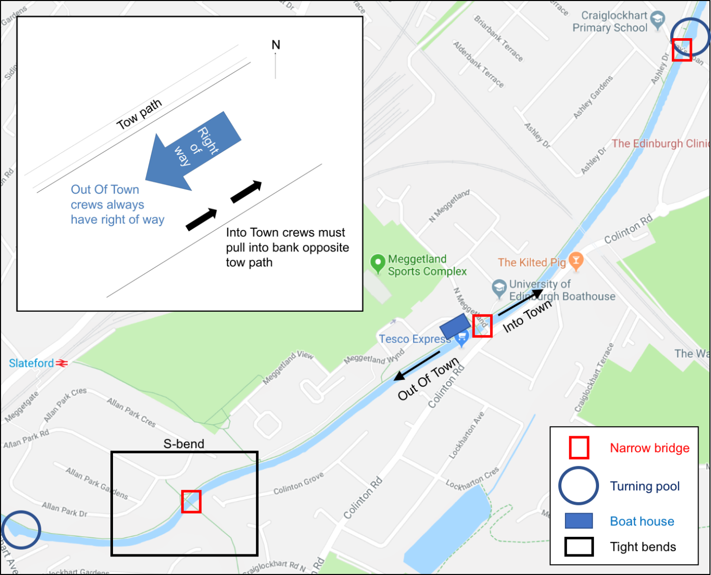

## Useful Links:

Scottish Rowing [www.scottish-rowing.org.uk](http://www.scottish-rowing.org.uk)

Strathclyde Park [www.northlanarkshire.gov.uk](http://www.northlanarkshire.gov.uk)

Weather [www.bbc.co.uk/weather](http://www.bbc.co.uk/weather)

British Rowing [www.britishrowing.org](http://www.britishrowing.org)